2018 AP Macro Exam
- Which of the following typically occurs during an expansionary phase of a business cycle?
(A) Nominal interest rates decrease.
(B) Income taxes decrease.
(C) The price level decreases.
(D) Government transfer payments increase.
(E) Employment increases.
- If both the nominal interest rate and the expected inflation rate increase, what will happen to the real interest rate?
(A) It will increase because the expected inflation rate has increased.
(B) It will increase because the nominal interest rate has increased.
(C) It will increase if the expected inflation rate increases by more than the nominal interest rate.
(D) It will decrease because the nominal interest rate has increased.
(E) It will decrease if the expected inflation rate increases by more than the nominal interest rate.
- Which of the following statements is true about an expansionary fiscal policy?
(A) It decreases demand for loanable funds.
(B) It decreases the equilibrium price level.
(C) It decreases the equilibrium real interest rate.
(D) It increases aggregate demand.
(E) It increases the money supply.
- Which of the following will most likely result from deflation?
(A) Increased nominal interest rates
(B) Increased business profits
(C) Increased real value of fixed incomes
(D) Decreased purchasing power of cash
(E) Decreased real wealth
- Which of the following is a defining characteristic of a fractional reserve banking system?
(A) The existence of a central bank with a monopoly on money creation
(B) The use of paper money backed by a commodity such as gold or silver
(C) The fact that banks retain an amount of bank reserves that is less than the amount of customer demand deposits
(D) The requirement that banks maintain a certain percentage of their reserves as a deposit in an account at the central bank
(E) The regulations that separate investment banking from commercial banking
- An increase in the purchases of newly constructed houses will result in which of the following?
(A) Aggregate demand will decrease as a result of a decrease in the price level.
(B) Aggregate demand will increase as a result of an increase in investment spending.
(C) Aggregate demand will increase as a result of an increase in exports.
(D) Aggregate demand will not change, since consumer spending has not changed.
(E) Aggregate demand will not change, since investment spending has not changed.
- Suppose that a country’s nominal gross domestic product (GDP) was $1,000 in year 1 and $2,000 in year 2. If year 1 is the base year and real GDP in year 2 was $1,000, which of the following is true?
(A) Prices fell by 50% between year 1 and year 2.
(B) Prices doubled between year 1 and year 2.
(C) Prices remained the same between year 1 and year 2.
(D) More goods and services were produced in
year 2 than in year 1.
(E) Fewer goods and services were produced in
year 2 than in year 1.
- Which of the following types of unemployment is caused by a recession?
(A) Hidden
(B) Frictional
(C) Seasonal
(D) Structural
(E) Cyclical
- If the United States government increases deficit spending, which of the following will occur as a result of the change in the interest rate?
(A) The United States dollar will appreciate in foreign exchange markets.
(B) Household savings in the United States will decrease.
(C) The United States exports will increase.
(D) The demand for United States dollars will decrease.
(E) Private investment in plant and equipment in the United States will increase.
- How will an increase in demand and a simultaneous decrease in supply affect the equilibrium price and quantity of a good in a market?
Price Quantity
(A) Increase Increase
(B) Increase Indeterminate
(C) Decrease Increase
(D) Decrease Indeterminate
(E) Indeterminate Indeterminate
- An increase in government spending financed by increased borrowing will most likely change the real interest rate and the gross private domestic investment in which of the following ways?
Real Interest Rate , Gross Private Domestic Investment
(A) No change No change
(B) Decrease Increase
(C) Decrease Decrease
(D) Increase Decrease
(E) Increase Increase

- Assume that an economy produces just two goods, X and Y, as shown in the table above. If year 1 is the base year, the consumer price index for year 2 in this economy is 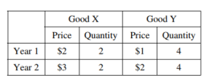
(A) 57.1
(B) 66.7
(C) 100
(D) 175
(E) 250
- Pat deposits a portion of her wages into a personal savings account every week. The saved money can be considered to be primarily a
(A) means of payment
(B) unit of account
(C) store of value
(D) measure of value
(E) medium of exchange
- An increase in the number of which of the following will lead to an increase in the unemployment rate?
(A) Discouraged workers
(B) Business start-ups
(C) Self-employed persons
(D) Persons working 30 instead of 40 hours per week
(E) Persons quitting part-time jobs to look for full-time ones
- Assume that the marginal propensity to consume is 0.8. If the government increases its purchases of goods and services by $200 and exports decline by $50, at most the equilibrium level of income will
(A) decrease by $250
(B) decrease by $1,000
(C) increase by $150
(D) increase by $750
(E) increase by $1,250
- An ongoing increase in the price of oil will result in
(A) demand-pull inflation
(B) cost-push inflation
(C) expansionary fiscal policy
(D) a decrease in the prices of substitute forms
of energy
(E) deflation
- Assume that Country X and Country Y are trading partners. If the average income in Country X increases, which of the following will occur in the foreign exchange market?
(A) The demand for Country X’s currency will increase, and Country X’s currency will appreciate.
(B) The demand for Country Y’s currency will increase, and Country X’s currency will depreciate.
(C) The demand for Country Y’s currency will increase, and Country X’s currency will appreciate.
(D) The supply of Country X’s currency will decrease, and Country X’s currency will appreciate.
(E) The supply of Country Y’s currency will increase, and Country Y’s currency will depreciate.
- Which of the following monetary and fiscal policy mixes will reduce unemployment?
(A) Buying government bonds in the open market and increasing taxes
(B) Buying government bonds in the open market and decreasing taxes
(C) Selling government bonds in the open market and increasing government spending
(D) Selling government bonds in the open market and decreasing government spending
(E) Selling government bonds in the open market and increasing taxes
- Which of the following is correct according to the circular flow model of an economy?
(A) Taxes received from the public equal government spending.
(B) Imports equal exports.
(C) Total spending equals total income.
(D) Consumption plus saving equals investment.
(E) Saving plus investment equals imports plus exports.
- Sam and Bill run a leaf raking and lawn mowing business. In one day, Sam can rake 3 lawns or mow 5 lawns whereas Bill can rake 2 lawns or mow 6 lawns. Which of the following correctly describes Sam’s and Bill’s absolute and comparative advantages?
(A) Sam has a comparative advantage in raking and an absolute advantage in mowing.
(B) Sam has a comparative advantage in mowing and an absolute advantage in raking.
(C) Sam has a comparative advantage in mowing and an absolute advantage in mowing.
(D) Bill has a comparative advantage in mowing and an absolute advantage in mowing.
(E) Bill has a comparative advantage in raking and an absolute advantage in mowing.
- People who have given up looking for jobs are classified as
(A) cyclically unemployed
(B) frictionally unemployed
(C) structurally unemployed
(D) discouraged workers
(E) underemployed workers
- The economy is currently in long-run equilibrium. If the central bank increases the money supply, in the long run the price level will
(A) increase, and output will remain at the full-employment level
(B) increase, and output will be above the full-employment level
(C) increase, and output will be below the full-employment level
(D) remain unchanged, and output will remain at the full-employment level
(E) remain unchanged, and output will be above the full-employment level
- The crowding out effect of government spending will be large if
(A) investment is highly sensitive to changes in the interest rate
(B) consumption is highly sensitive to changes in wealth
(C) money demand is highly insensitive to changes in income
(D) it takes a long time for changes in government spending to cause a change in equilibrium income
(E) the long-run aggregate supply curve is horizontal

- Which of the following will occur in the money market when the aggregate price level increases?
(A) The money supply will increase and nominal interest rates will decrease.
(B) The demand for money will increase and nominal interest rates will decrease.
(C) The demand for money will increase and nominal interest rates will increase.
(D) The demand for money will decrease and nominal interest rates will decrease.
(E) The opportunity cost of holding money will decrease.
- Increases in government subsidies to encourage investment in research and development will affect aggregate demand (AD) and long-run aggregate supply (LRAS) in which of the following ways?
AD LRAS
(A) Increase Increase
(B) Increase Decrease
(C) Increase No change
(D) Decrease Increase
(E) Decrease No change
- If an automobile was manufactured in 2006 and sold to a consumer in 2007, what was the effect on gross domestic product in 2006 and 2007?
2006 2007
(A) No change Increase
(B) Decrease Increase
(C) Increase No change
(D) Increase Decrease
(E) No change No change
- Which of the following is true when interest rates rise?
(A) The opportunity cost of holding cash decreases.
(B) The opportunity cost of holding cash increases.
(C) The opportunity cost of holding cash stays the same.
(D) The money demand curve shifts to the right.
(E) The money supply curve shifts to the right.

- The table above gives population and labor-market data for an economy. The unemployment rate in this economy is 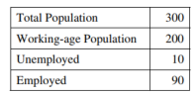
(A) 3.3%
(B) 5%
(C) 10%
(D) 33.3%
(E) 50%
- In the short run, how would a government’s budget deficit, national debt, and real output change if government spending increases with no change in taxes?
Deficit Debt Real Output
(A) Increase Increase Decrease
(B) Increase Decrease Increase
(C) Increase Increase Increase
(D) Decrease Decrease Increase
(E) Decrease Increase Decrease

- The graph above shows the production possibilities curves (PPC) for an economy. The concept of opportunity cost is best represented by which of the following? 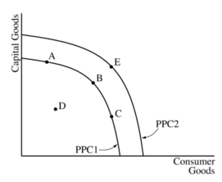
(A) A shift from PPC1 to PPC2
(B) A movement from point A to point D
(C) A movement from point B to point C
(D) A movement from point C to point E
(E) A movement from point D to point B
- A bank has $200 million in demand deposits and $150 million in reserves. The reserve ratio is 20 percent. What is the maximum amount of loans the bank can make from its reserves?
(A) $750 million
(B) $150 million
(C) $110 million
(D) $50 million
(E) $40 million
- When the total amount the government spends equals tax revenues in any given year, which of the following must remain constant?
(A) The real interest rate
(B) The national debt
(C) Real gross domestic product
(D) The price level
(E) The money supply
- How does the automatic adjustment mechanism move the economy to potential real gross domestic product (GDP) in the long run when current real GDP is above potential GDP?
(A) Nominal wages fall, shifting the short-run aggregate supply curve to the right.
(B) Nominal wages fall, shifting the short-run aggregate supply curve to the left.
(C) Nominal wages do not change, shifting the short-run aggregate supply curve to the right.
(D) Nominal wages rise, shifting the short-run aggregate supply curve to the right.
(E) Nominal wages rise, shifting the short-run aggregate supply curve to the left.
- Which of the following statements about inflation is true?
(A) The expected inflation rate is the difference between nominal and real interest rates.
(B) Low expected inflation rates lead to high inflation rates.
(C) Lenders lose from expected inflation.
(D) Lenders gain from unexpected inflation.
(E) Workers lose from expected inflation.
- If consumers in Canada increase their demand for products that are manufactured in India, which of the following will occur?
(A) The Indian rupee will depreciate.
(B) The Canadian dollar will appreciate.
(C) India’s financial capital inflow will increase.
(D) Canada’s financial capital inflow will increase.
(E) The supply of Canadian dollars will decrease.
1 | E | 11 | D | 21 | D | 31 | C
2 | E | 12 | D | 22 | A | 32 | B
3 | D | 13 | C | 23 | A | 33 | E
4 | C | 14 | E | 24 | C | 34 | A
5 | C | 15 | D | 25 | A | 35 | D
6 | B | 16 | B | 26 | C | 36
7 | B | 17 | B | 27 | B | 37
8 | E | 18 | B | 28 | C | 38
9 | A | 19 | C | 29 | C | 39
10 | B | 20 | D | 30 | C | 40

Free Response Secction
- Assume a country’s economy is currently in recession.
(a) Draw a correctly labeled graph of the long-run aggregate supply, short-run aggregate supply, and aggregate demand curves, and show each of the following.
(i) Current real output, labeled Y1, and current price level, labeled PL1
(ii) Full employment output, labeled Yf
(b) Identify one action the central bank can take to help the economy recover from the recession.
(c) Draw a correctly labeled graph of the money market, and show the impact of the central bank’s action identified in part (b) on the nominal interest rate.
(d) On your graph for part (a), show the effect of the central bank’s action identified in part (b) on real outputand the price level.
(e) Assume there is an increase in business confidence as a result of the central bank’s action.
(i) What will happen to the demand for capital goods?
(ii) Draw a correctly labeled graph of the loanable funds market, and show the effect of the change identified in part (e)(i) on the real interest rate.
(f) Given your answer to part (e), what is the effect on potential real output in the long run? Explain.
- The exchange rate between the Australian dollar and the Indian rupee is determined in a flexible foreign exchange market.
(a) Assume India is currently in recession. What fiscal policy action could the Indian government take to eliminate the recession?
(b) What would be the effect of the fiscal policy action identified in part (a) on interest rates in India?
(c) Draw a correctly labeled graph of the foreign exchange market for the Australian dollar. Show on your graph the impact of the change in interest rates identified in part (b) on each of the following.
(i) The supply of Australian dollars
(ii) The equilibrium exchange rate of the Australian dollar
(d) What would be the effect of the change in the exchange rate identified in part (c)(ii) on Australian exports?
(e) What would be the effect of the change in Australian exports identified in part (d) on Australian
unemployment?
- Gross domestic product (GDP), unemployment, inflation, and economic growth are key measures of a country’s economic performance.
The following statistics are from the country of Pattiland in 2016; dollar values are measured in 2016 dollars
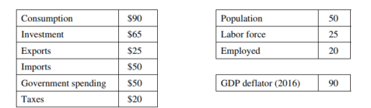
(a) Calculate each of the following and show your work.
(i) Nominal GDP
(ii) Real GDP
(iii) Real GDP per capita
(b) Debbie is a citizen of the country of Wayland and owns a computer software firm in Pattiland. Is the outputproduced by Debbie’s computer software firm included in Pattiland’s nominal GDP calculated in part (a) ? Explain.
(c) The GDP deflator for Pattiland in 2015 was 110. In 2016 was Pattiland experiencing inflation or deflation,or is there insufficient information to determine Pattiland’s economic condition? Explain.
(d) Calculate the unemployment rate in Pattiland.

Answers FR:

a.
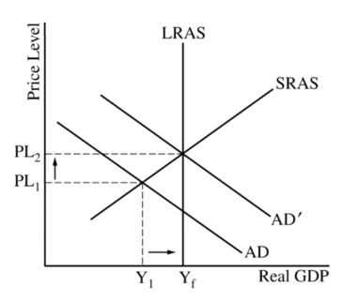
b. buy bonds, decrease discount rate, decrease RRR
c.
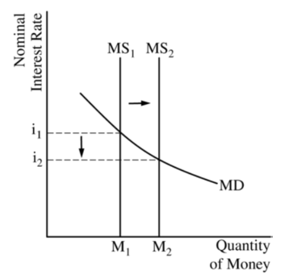
d. Increase AD, Increase Output, Increase Price Level
e.
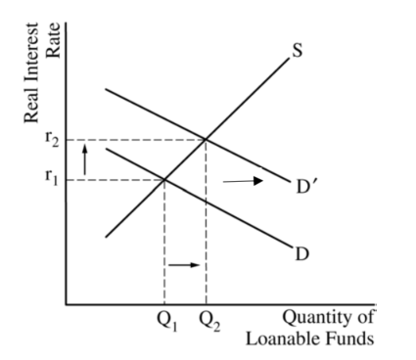
f. LRAS shift to right and Yp shift to right

Q2
a) One point is earned for stating that the government should either increase its expenditures (or purchases) or decrease taxes
b) One point is earned for stating that interest rates will increase.
c) 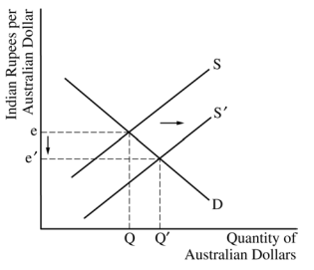
d) • One point is earned for stating that Australian exports will increase.
e) • One point is earned for stating that Australian unemployment decreases.
Q3
- Nominal GDP = 90 + 66 + 50 + 25 – 50
Nominal GDP because 2016 GDP given in 2016 prices.
GDP Deflator = (Nominal GDP/Real GDP) x 100
Therefore, Real GDP = (Nominal GDP / GDP Deflator) x 100
Therefore Real GDP = 180/90) x 100 = 200
Real GDP per capita = Real GDP / population = 200/50 = 4
- Will be counted because producing final goods within the geographic borders of Pattiland.
- Pattiland is experiencing deflation. GDP deflator falls from 110 to 90. Any decrease in GDP deflator from one year to the next means deflation.
- Unemployment rate = 5/25x100=20%

